**You don't need a 200MP phone, but Motorola does it anyway**

**How many pixels are too many?**

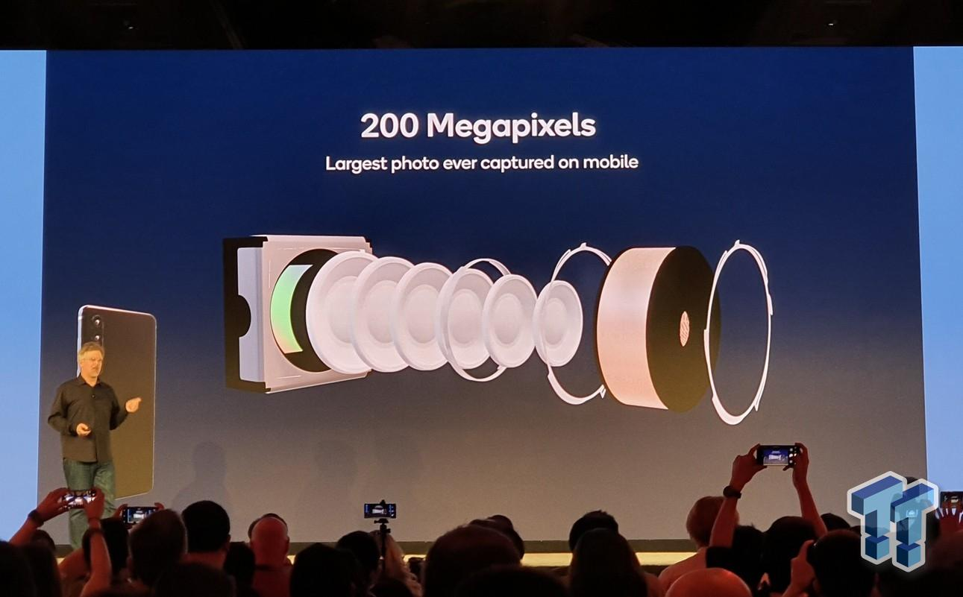

In the past, 8 megapixels on a smartphone camera was a big deal. The 50 megapixels had previously been impressive. Then came the 100 MP phones and that was clean with it, I think.

But does anyone want 200 megapixels? That's what Motorola looks like with its upcoming flagship phones.

The general manager of Lenovo sent a mock image of the 200-megapixel smartphone to Weibo (Lenovo owns Motorola). The post did not reveal much about the device beyond the release date of July, although a different post mocked the folding device (probably the Razr 3) playing the new Snapdragon 8+ Gen 1 chip.



Let's be clear: 200 megapixels on the phone are very powerful. There are advantages to high resolution, but even the most expensive cameras in the world do not reach such decisions naturally.

The Hasselblad H6D-400C, a $ 47,000 camera, can reach up to 400 megapixels by combining multiple images into one, but its actual sensor is only 100 megapixels. Phase One's XT IQ4, at 150 megapixels, has the highest native sensor resolution available on the prosumer camera, and that costs $ 57,000.

If professionals don’t need that kind of resolution on their cameras, you don’t need it on your smartphone. As a reference, 4K is 8.3 megapixels and 8K is "only" 33.2 megapixels.

Also, there are some advantages to that type of information. When smartphones use such high resolution, they rarely end up producing high-megapixel images. Instead, they successfully combine multiple pixels in a process called “pixel-binning,” which can improve the performance of low light, flexibility, and color rendering. So instead of a 200-megapixel image, you will probably end up with a 12-ish megapixel image instead.

Likewise, high-resolution sensors are an easy way to allow people to “zoom” in scenes without having to install a large telephoto lens (zoom is a quote because everything you do is crop) to a smaller device.

But using a high-resolution sensor has no problems. It requires a lot of processing and storage power when images are stored in high resolution. And even with captured images, the image quality benefits are overlooked when compared to using the low-resolution sensor.

Perhaps even more important, such high resolution is not possible to make a significant difference in image quality.

First of all, the lenses on smartphones can’t just solve many details. Few lenses on professional cameras can solve that kind of adjustment, let alone small vision on smartphones.

Also, we have consistently seen that image processing is far more important than the latest digital hardware these days. There is a reason why Google Pixel phones were able to produce some of the best images among the handsets available at the time while using classic hardware.

But 200 megapixels sound better, say, 50 megapixels. So 200 megapixels.

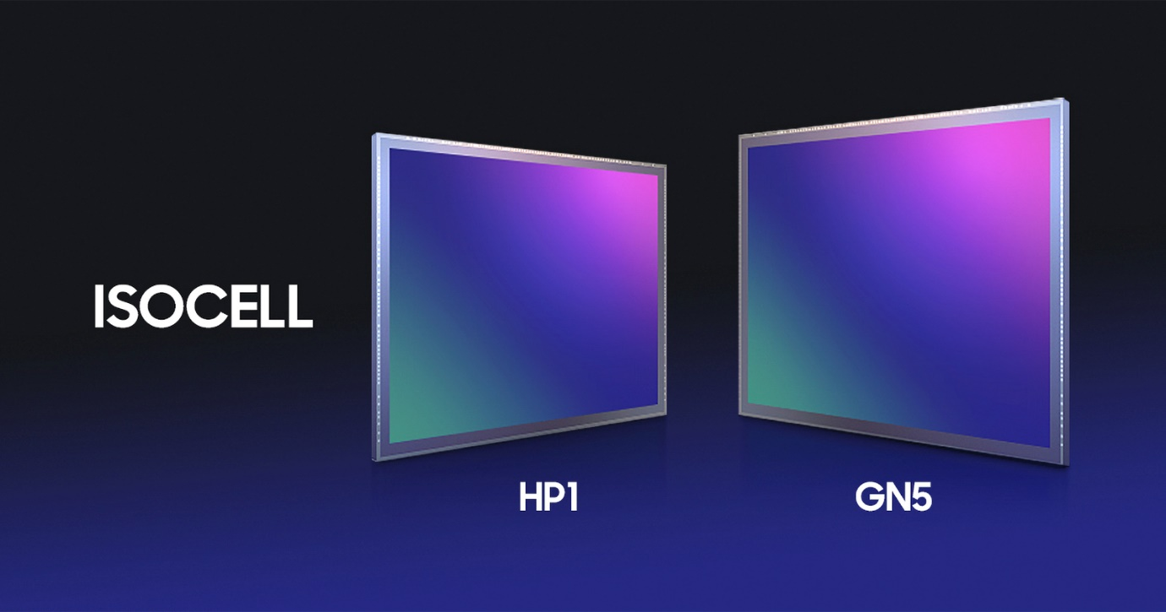

To be honest, we know that 200-megapixel phones are coming a long way now. The next Motorola phone may be using the Isocell HP1, a sensor announced by Samsung last year.

But as is often the case, it took a long time for the sensor to discover. Samsung itself is not expected to use this sensor until next year's S23. And that delay is possible because even Samsung knows that it does not need the latest and greatest hardware to achieve good images.

With most smartphone history, the image quality has little to do with editing. Phones that are generally considered to be the best cameras are rarely the ones with the highest resolution sensors, and that is unlikely to change with any Motorola cooker. High megapixel counting is a party trick, but we hope the company pays more attention to image processing than numbers on a particular sheet.